**Create ChatBot Using Python :**

There was so many ways to create a chatbot using python. So, I used Google colab for creating a chatbot using python.

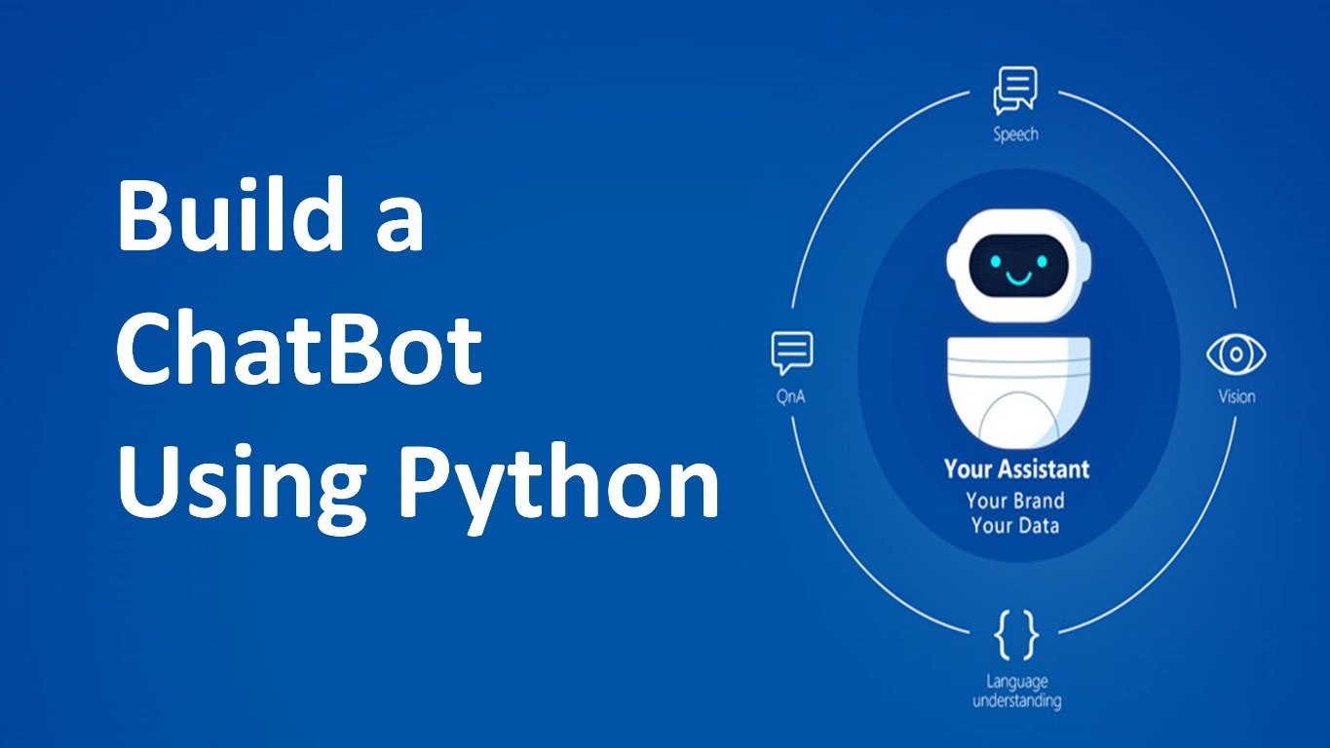

There was some steps to create it:

Step 1: Define the Purpose and Scope

Before you start coding, have a clear understanding of what your chatbot will do. Determine its purpose, target audience, and the tasks it will perform.

Step 2: Choose a Framework or Library

There are various libraries and frameworks available for creating chatbots in Python.

Some popular options include:

- **NLTK (Natural Language Toolkit**) : A library for working with human language data, providing easy-to-use interfaces for tasks like tokenization, stemming, tagging, parsing, and more.

- **spaCy** : Another NLP library that's more focused on providing industrial-strength, highly optimized NLP tools.

- **Rasa :** An open-source framework for building conversational AI. It provides tools to handle NLU (Natural Language Understanding) and dialogue management.

- **Chatterbot** : A library for creating chatbots in Python which uses a selection of machine learning algorithms.

- **Dialogflow (formerly API.ai)** : A cloud-based NLP platform that provides a set of tools for building conversational interfaces.

Step 3: Set Up the Development Environment

Make sure you have Python installed on your system. You can download it from the official [Python website](https://www.python.org/). It's also recommended to use a virtual environment to manage dependencies.

# Create a virtual environment

python3 -m venv myenv

# Activate the virtual environment

source myenv/bin/activate # On Windows, use: myenv\Scripts\activate

Step 4: Install Dependencies

Depending on the framework or library you choose, you'll need to install the necessary packages. For example, if you're using Rasa, you can install it using:

**pip install rasa**

Step 5: Design the Conversational Flow

Create a flowchart or outline of how the conversation will progress. Determine the key intents, entities, and responses the chatbot will handle.

Step 6: Implement Natural Language Processing (NLP)

This step involves processing user input to understand the user's intent and extract relevant information. If you're using a library like Rasa or Dialogflow, they provide tools to handle NLP.

Step 7: Implement Backend Logic

Based on the user's input and intent, implement the backend logic to perform the desired actions. This could involve querying databases, calling APIs, performing calculations, etc.

Step 8: Handle Dialog Management

Keep track of the conversation context to maintain a coherent and natural conversation. This involves managing states, maintaining context, and generating appropriate responses.

Step 9: Test the Chatbot

Test the chatbot thoroughly to ensure it handles various user inputs and scenarios. Debug and refine the responses as needed.

Step 10: Deploy the Chatbot

Depending on your requirements, you can deploy the chatbot on various platforms. This could be a website, messaging app, or a dedicated chatbot platform.

Step 11: Monitor and Improve

Continuously monitor the chatbot's performance and gather user feedback. Use this information to make improvements, add new features, and enhance the user experience.

These are the right ways to create a chatbot.

**Project Output ScreenShot :**

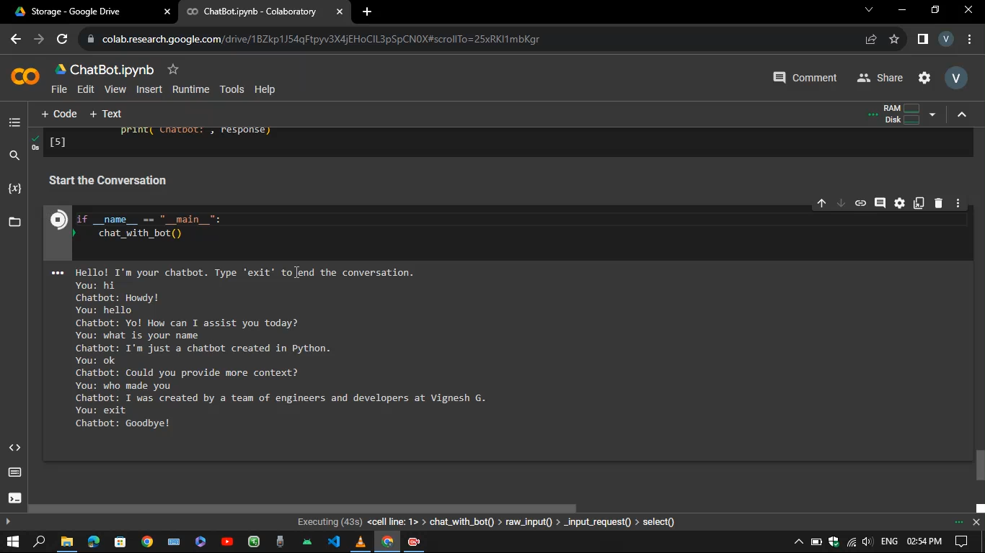

**Project Link Github :**

[*https://github.com/Sweety-Vigneshg/ChatBot-using-Python/tree/main/ChatBot%20using%20Python*](https://github.com/Sweety-Vigneshg/ChatBot-using-Python/tree/main/ChatBot%20using%20Python)

**DataSet Link :**

[*https://github.com/Sweety-Vigneshg/ChatBot-using-Python/tree/main/ChatBot%20using%20Python/Dataset*](https://github.com/Sweety-Vigneshg/ChatBot-using-Python/tree/main/ChatBot%20using%20Python/Dataset)

**Video Demo :**

[*https://github.com/Sweety-Vigneshg/ChatBot-using-Python/tree/main/ChatBot%20using%20Python/Report%20and%20Video%20Demonstration*](https://github.com/Sweety-Vigneshg/ChatBot-using-Python/tree/main/ChatBot%20using%20Python/Report%20and%20Video%20Demonstration)

**Source Code :**

[*https://github.com/Sweety-Vigneshg/ChatBot-using-Python/tree/main/ChatBot%20using%20Python/Training*](https://github.com/Sweety-Vigneshg/ChatBot-using-Python/tree/main/ChatBot%20using%20Python/Training)

**Project Submitted By**

**Vignesh G**

**814621104059@trichyengg.ac.in**